Purpose
This power analysis was created by Brian Crawford (Compass Resource Management) and Pascale Goertler (DWR), in consultation with Jacob Montgomery (CalTrout).
The analysis focused on HBypassFP2: …
Data and preparation
We drew on available data from the Fish Food Pilot Program monitoring floodplain actions in the Colusa Basin near Knights Landing, CA. We consulted Jacob Montgomery to access data (https://portal.edirepository.org/nis/metadataviewer?packageid=edi.996.3) and interpret how to apply it to the power analysis.
At Jacob’s advice, we filtered data to only include samples from 2019 and 2021. Data from other years still needs QA/QC but could be available in the future. We also filtered data to only include samples from key locations in the main experimental site of the Fish Food Pilot Program (although the original datasets included other monitoring locations further away). See table below.

Figure 1. Zooplankton concentration vs. distance from bypass floodplain outfall for the two years with available data.
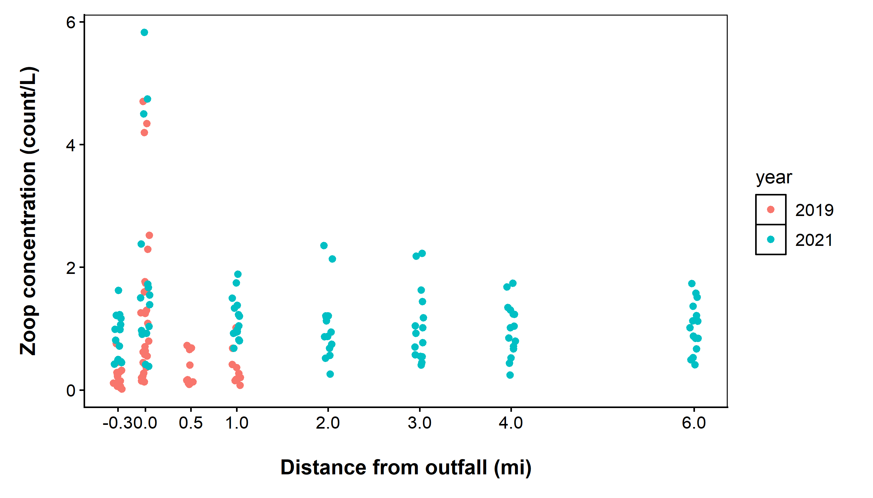
The exploratory model
A subgroup of Science Committee members met to discuss candidate models and key covariates that may influence zooplankton densities from this action, which should be considered for this analysis and future monitoring. We originally considered using the model:
zooplankton (total concentration) ~ treatment (upstream control vs. treated area) + distance from outfall + DO + temp + daily flow rate (cfs) + (1 | year)
where each variable and data are described below.
Variable | Notes and source
Zooplankton concentration | Primary response variable of interest. We calculated total zooplankton concentration by summing weights
Treatment | Assigned based on location of upstream or downstream of the outfall that would receive water from the floodplain site. Jacob Montgomery confirmed which sites to include as controls vs. treatment.
Distance from outfall | Ranged from -0.3 (upstream) to 6 miles downstream. Assigned using Table 1 in CalTrout’s report (see table below) and confirmed by Jacob Montgomery.
DO | In mg/L. Included in CalTrout data.
Temperature | In °C. Included in CalTrout data.
Daily flow rate | Daily flow rate (cfs) was taken from the closest gauge with continuous data in the analysis timeframe. This was in the Sacramento River at Wilkins Slough (USGS-11390500). Data available here.
Year | Random effect for year (2019 and 2021).
Due to the imbalanced sampling design across distances and years (see Figure 1), we explored a simplified model for 3 separate pairwise comparisons between the control site and treated sites 0, 1, and 6 mi downstream. For each distance, we tested for collinearity among predictors and performed model comparison for a global model and all subsets that included: treatment, DO, temperature, and daily flow rate.
Model comparison results showed the same model ranking best or second-best across the three distances. Therefore, we used the same final model for running a simulation-based power analysis comparing control sites to treated sites 0, 1, and 6 mi downstream:
zooplankton (total concentration) ~ treatment (upstream control vs. treated area) + daily flow rate (cfs)
We performed the power analysis at each distance downstream under a range of assumed effects on zooplankton concentration, 0.2x to 5x increase in concentration relative to the upstream control site, and ran the simulation for 5,000 iterations to summarize results.
All data, code, and results are available on GitHub here.
Results
The power analysis showed power obtained from different sample sizes varies strongly by the assumed increase in zooplankton concentration and also varies by location downstream. In general, 15-20 samples per site are predicted to yield sufficient power to detect a >2x increase in zooplankton at the outfall (distance = 0), whereas 10 samples per site are predicted to yield sufficient power to detect a >1x increase at sites 1 to 6 mi downstream.
Based on these results, collecting 10-15 samples per site in a balanced design across distances downstream could provide sufficient power, assuming zooplankton increases of 2x or higher.
Figure 2. Power vs. sample size assuming a range of different effects in zooplankton concentration at three “treated” locations in the Sacramento River, relative to a control site upstream.
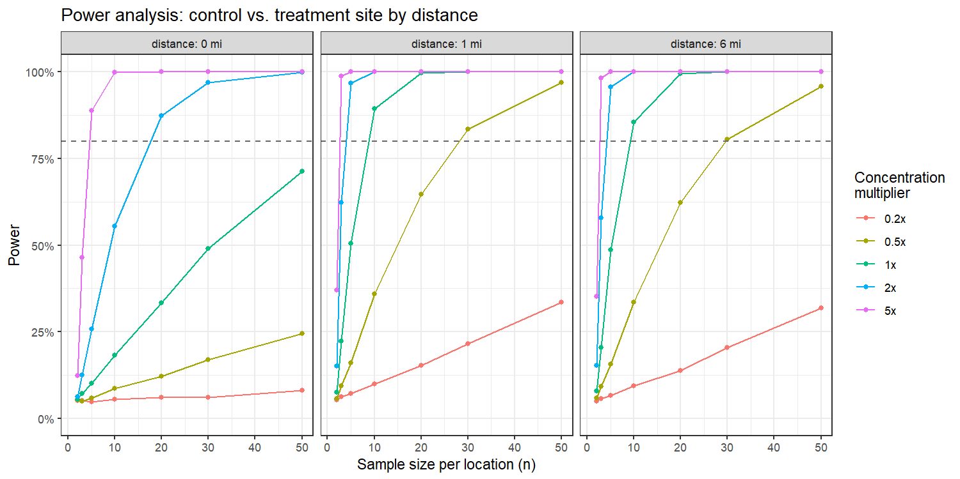
Interpreting these results for HRL site monitoring
The Fish Food Pilot Program action took place in the Colusa Basin that drained into the Sacramento River. When interpreting results from a power analysis on this data and applying them to the Yolo and Sutter Bypass projects in HRL, several contextual factors need to be considered including: the magnitude of flow, the diversity of inputs, the distance from the actions to where monitoring, and tidal mixing.
- In practice for Yolo and Sutter Bypass actions, recommend decreasing distances for monitoring (0.25 mi, 1 mi, and 2 mi downstream) because these are smaller flow/smaller scale projects than Fish Food Program. As observed in the Fish Food Pilot Program data (see Figure 1), the strongest increases in zooplankton will likely be detectable closer to the outfall.
- In Yolo Bypass, recommend considering effects of tides, and consider timing the monitoring protocols with tides (affects “distance”, as tides could push zooplankton-rich water generated from bypasses above outlets).
- Recommend using control/reference site in the region that will not be impacted by the bypass floodplain action or tidal influence (maybe near Putah and Cache Creek outflows).
- Recommend accounting for seasonal context (what water year type is it, is it early or late in the season, what are the pre-action flows and zoop levels, were there major flood events before action, etc.).
- Recommend a balanced sampling design across years and sites at different locations downstream to test the influence of additional covariates in statistical models.

